Energy in Chemistry

1.  *Energy*- is anything that has the capacity to do work.

Work is a force acting over a distance.

Energy = work = force × distance

Chemical systems undergo three main processes that change their energy; heating/cooling, phase transitions and chemical reactions.

2. *Classification of Energy*

**Kinetic energy** is energy of motion or energy that is being transferred.

KE = ½ mv2 m= mass v = velocity

**Potential energy** is energy that is stored in an object, or energy associated with the composition and position of the object. It is associated with a particular geometric arrangement of atoms or ions and the electrostatic interactions ( + and – charges) between them.

**Thermal energy** is the energy associated with temperature. Thermal energy is a form of kinetic energy.

**Units of Energy** –

*Joule (J*) = amount of energy needed to move a 1 kg mass a distance of 1 meter.

1 J = 1 N ∙ m = 1 kg ∙ m2/s2

*calorie (cal)* = amount of energy needed to raise the temperature of 1 gram of H2O 1 °C.

kcal = energy needed to raise 1000 g of water 1 °C, food Calories = kcals

3. *Energy, Heat, and Work*

You can think of energy as a quantity an object can possess.

Heat and work are two different ways that an object can exchange energy with other objects.

Heat is the flow of energy caused by a difference in temperature.

Energy can be exchanged between objects through contact, for example, through collisions

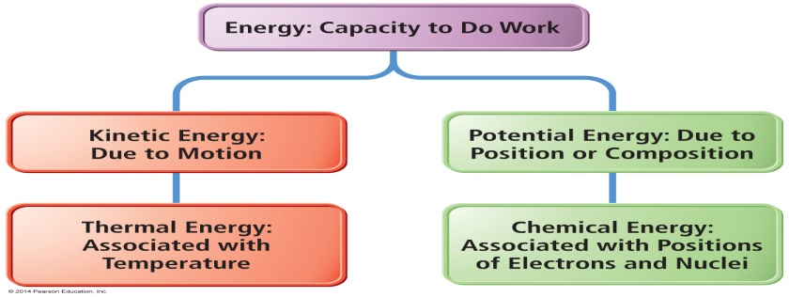

4. *Forms of Energy*

Electrical -Kinetic energy associated with the flow of electrical charge

Heat or thermal energy- Kinetic energy associated with molecular motion

Light or radiant energy- Kinetic energy associated with energy transitions in an atom

Nuclear- Potential energy in the nucleus of atoms

Chemical- Potential energy due to the structure of the atoms, the attachment between atoms, the atoms’ positions relative to each other in the molecule, or the molecules’ relative positions in the structure.

5. *Conservation of Energy*

The law of conservation of energy states that energy cannot be created nor destroyed. When energy is transferred between objects, or converted from one form to another, the total amount of energy present at the beginning must be present at the end.

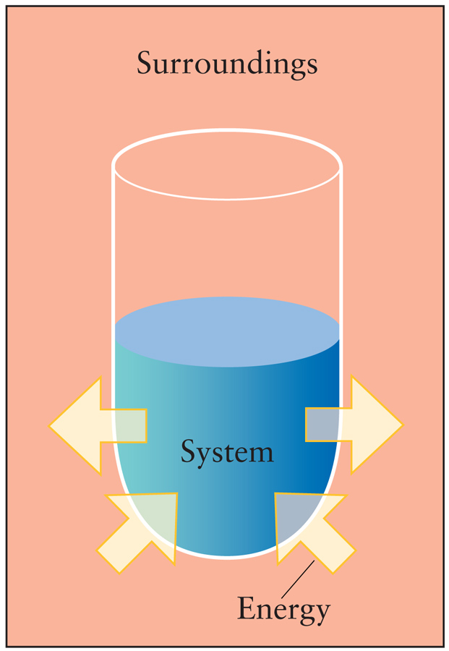

6. *Where energy exchanges occur*

System + Surroundings = Universe

*System* as the material or process within which we are studying

the energy changes within.

*Surroundings* as everything else with which the system can exchange energy.

What we study is the exchange of energy between the system and the surroundings.

7. Conservation of energy requires that the sum of the energy changes in the system and the surroundings must be zero.

∆EnergyUniverse = 0 = ∆EnergySystem + ∆EnergySurroundings

8. *Internal Energy*

The internal energy is the total energy of the system. This is the energy that can be exchanged with the surroundings.

E = q + w E = internal energy q = heat w= work

When energy flows out of a system, ∆Esystem is negative.

When energy flows into the surroundings, ∆Esurroundings is positive.

The only way energy can be exchanged is by a change in heat or by work being done. In chemistry we focus on heat.

*A. Heat*

Heat is the exchange of thermal energy between a system and surroundings.

Heat exchange occurs when system and surroundings have a difference in temperature.

Temperature is the measure of the thermal energy within a sample of matter.

Temperature is proportional to the average kinetic energy of the atoms or molecules in a sample.

Heat flows from matter with high temperature to matter with low temperature until both objects reach the same temperature, thermal equilibrium

*B. Work*

Work = force X distance.

In chemistry Work = P∆V. Work that occurs when the volume, *V* of a system changes. Think of Boyle’s Law.

When the system expands work is done by the system on the surroundings

When the system contracts, work is done by the surrounding on the system

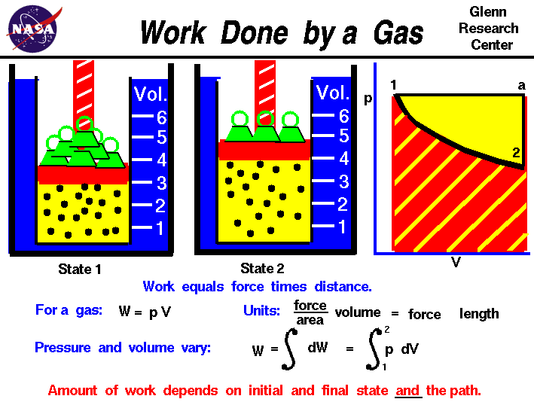

9. *Energy movement-*

**Energy Exiting system to surroundings = EXOTHERMIC**

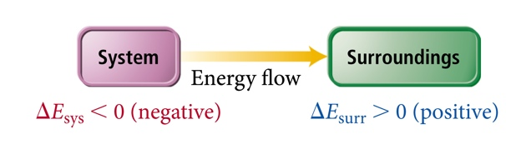

─ ∆Esystem= ∆Esurroundings

**Energy Entering system from the surroundings = ENDOTHERMIC**

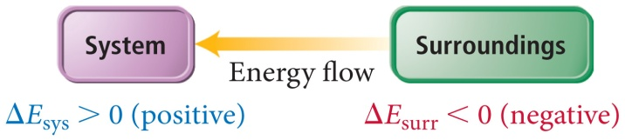

∆Esystem= ─ ∆Esurroundings

10. *Energy movement in a system in a chemical reaction*

System: C(s), O2(g) ,CO2(g)

Surroundings: Everything else

In the reaction **C(s) + O2(g) → CO2(g),** there will be a net release of energy into the surroundings.

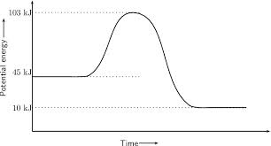

Energy of reactants is greater than the energy of the products. The difference is energy exits the system to the surroundings

In the reaction **CO2(g) → C(s) + O2(g),** there will be an absorption of energy from the surroundings into the reaction.

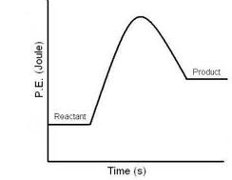

Energy of product is greater than the energy of the reactants. The difference is energy comes from the surroundings.